**BIPOLAR JUNCTION TRANSISTOR**

A Bipolar Junction Transistor (BJT) is a semiconductor device formed by two pn

junctions. Therefore, it will have three alternating regions. It can be either a narrow n-type region placed between two p type layers (forming a pnp transistor), or a thin p-type region between two n-type layers (representing a npn transistor).

**BJT OUTPUT CHARACTERISTIC**

* ***Theoretical Summary***

The output characteristic relates the output current with the output voltage ,

with the condition that the input current is kept constant:

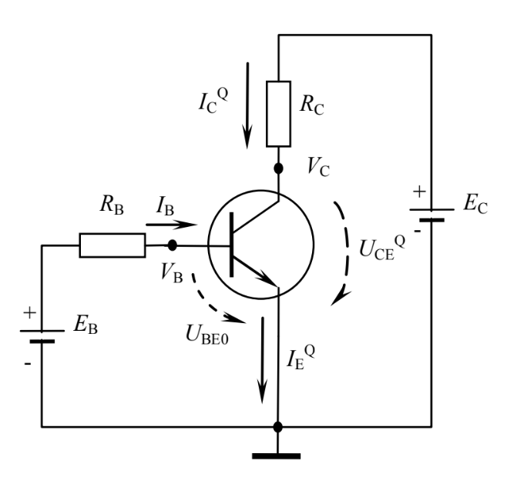

* ***Components***

1. *EB , EC – DC Voltage Sources*
2. *npn Transistor*
3. *RB – Base Resistor*
4. *RC – Collector Resistor*

* ***Values***
* RB = 100kΩ
* RC = 1kΩ
* EC
* I. EB = 1.6V => (KVL – left loop) => IB1 = 10mA
* II. EB = 2.6V => … => IB2 = 20mA
* ***Measurements***

|  |  |  |  |  |  |
| --- | --- | --- | --- | --- | --- |
| **EC[V]** | **UCE[V]** | **IC[mA]** | **EC[V]** | **UCE[V]** | **IC[mA]** |
| **0** | **0** | **0** | **0** | **0** | **0** |
| **1.13** | **0.1** | **1.03** | **1.13** | **0.07** | **1.06** |
| **1.37** | **0.11** | **1.26** | **1.29** | **0.08** | **1.21** |
| **1.92** | **0.12** | **1.8** | **1.34** | **0.08** | **1.26** |
| **2.2** | **0.13** | **2.07** | **1.5** | **0.08** | **1.42** |
| **2.6** | **0.15** | **2.45** | **1.73** | **0.09** | **1.64** |
| **2.88** | **0.16** | **2.72** | **2.25** | **0.1** | **2.15** |
| **3.11** | **0.18** | **2.93** | **2.53** | **0.11** | **2.42** |
| **3.39** | **0.2** | **3.19** | **2.8** | **0.12** | **2.68** |
| **3.61** | **0.24** | **3.37** | **3.18** | **0.13** | **3.05** |
| **3.72** | **0.28** | **3.44** | **3.53** | **0.13** | **3.4** |
| **4.03** | **0.5** | **3.53** | **4.17** | **0.15** | **4.02** |
| **4.35** | **0.79** | **3.56** | **4.73** | **0.16** | **4.57** |
| **4.84** | **1.22** | **3.62** | **5.12** | **0.17** | **4.95** |
| **5.18** | **1.53** | **3.65** | **5.78** | **0.19** | **5.59** |
| **6** | **2.28** | **3.72** | **6.27** | **0.22** | **6.05** |
| **7.32** | **3.5** | **3.82** | **6.6** | **0.24** | **6.36** |
| **8.4** | **4.5** | **3.9** | **7** | **0.27** | **6.73** |
| **8.97** | **5.02** | **3.95** | **7.5** | **0.37** | **7.13** |
| **10.33** | **6.3** | **4.03** | **8.15** | **0.78** | **7.37** |
| **10.78** | **6.7** | **4.08** | **8.94** | **1.4** | **7.54** |
| **11.35** | **7.23** | **4.12** | **9.47** | **1.82** | **7.65** |
| **12.2** | **8.06** | **4.14** | **9.89** | **2.16** | **7.73** |
|  |  |  | **10.49** | **2.64** | **7.85** |
|  |  |  | **10.75** | **2.85** | **7.9** |
|  |  |  | **11.21** | **3.22** | **7.99** |
|  |  |  | **11.57** | **3.5** | **8.07** |
|  |  |  | **12.04** | **3.9** | **8.14** |
|  |  |  | **12.2** | **4.02** | **8.18** |

* ***KVL (right loop):***
* ***Current Gain***

1. ***IB = 10mA***
2. ***IB = 20mA***

* ***Experimental Model***

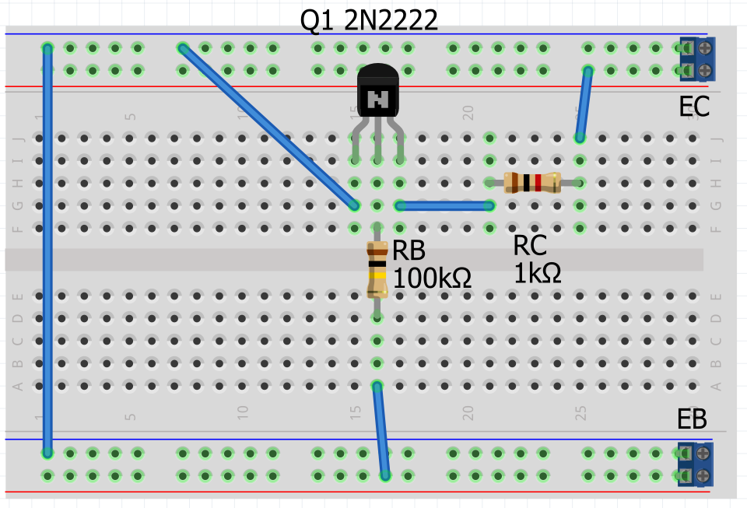

* ***Simulations***

|  |
| --- |
|  |
|  |

* ***Conclusion***

The collector current , and in turn the Q point’s current and voltage , depends on the value of the base current .

is directly proportional with .

**BJT VOLTAGE DIVIDER (SELF-BIAS)**

* ***Theoretical Summary***

The operating point (Q point or bias point) of the BJT is defined as the DC

component pair of the collector current and the collector – emitter voltage .

Graphically, the operating point is situated at the intersection of the load line and

the output I-V characteristic of the transistor.

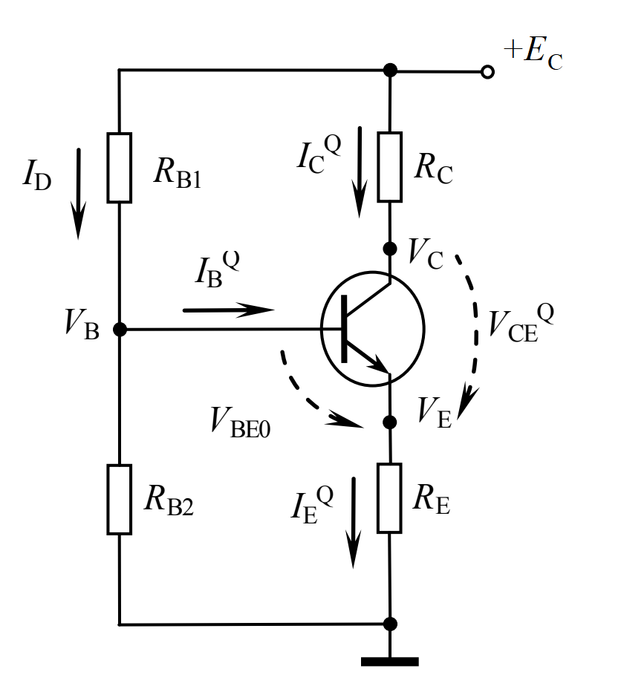

* ***Components***

1. *EC – DC Voltage Sources*
2. *npn Transistor*
3. *RB1 , RB2 – Base Resistors*
4. *RC – Collector Resistor*
5. *RE – Emitter Resistor*

* ***Values***
* EC = 12V
* RC = 2.2kΩ
* RE = 1kΩ
* Depending on the potentiometer:
  + I. P M: RB1 = 47kΩ & RB2 = 20kΩ
  + II. P N: RB1 = 57kΩ & RB2 = 10kΩ
* ***Theoretical Analysis & Calculations***
  + ***Thevenin Method***

|  |  |
| --- | --- |
| ***Linear Circuit Load*** |  |

1. **P M** : RB1 = 47kΩ & RB2 = 20kΩ
2. **P N** : RB1 = 57kΩ & RB2 = 10kΩ

|  |  |  |  |  |
| --- | --- | --- | --- | --- |
|  | **= 333** | | **= 130** | |
| **ICQ [mA]** | **UCEQ [V]** | **ICQ [mA]** | **UCEQ [V]** |
| **P M** | **2.85** | **2.88** | **2.69** | **3.39** |
| **P N** | **1.16** | **8.28** | **1.11** | **8.44** |

|  |
| --- |
| **= 333** |
|  |
| **= 130** |
|  |

* ***Experimental Model***

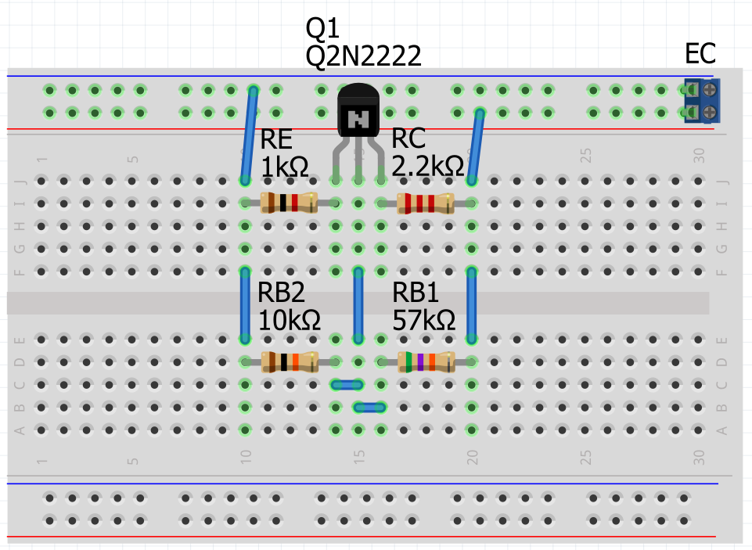

* ***Measurements***

|  |  |  |  |  |
| --- | --- | --- | --- | --- |
| **=**  **25°C** | **T1** | | **T2** | |
| **= 333** | | **= 130** | |
| **ICQ [mA]** | **UCEQ [V]** | **ICQ [mA]** | **UCEQ [V]** |
| **P M** | **2.83** | **2.95** | **2.64** | **3.54** |
| **P N** | **1.15** | **8.32** | **1.08** | **8.51** |

|  |
| --- |
| **= 333** |
|  |
| **= 130** |
|  |

* ***Simulations***

|  |  |
| --- | --- |
| **P M** | **P N** |
|  |  |
| **= 166**  **ICQ = 2.67mA**  **UCEQ = 3.44V** | **= 163**  **ICQ = 1.08mA**  **UCEQ = 8.53V** |
|  | |

* ***Conclusion***

The Q point of the self-bias voltage divider circuit depends more on the resistances at the base of the transistor, and , than the variation of the transistor’s current gain, .

**BJT AMPLIFIER**

* ***Theoretical Summary***

The typical voltage amplifier using a single BJT – common emitter connection. It can be observed that this circuit contains two voltage sources. The DC voltage source is required for biasing the transistor in the active region so that it can work as an amplifier. On the other hand, the AC source provides the variable signal to be amplified.

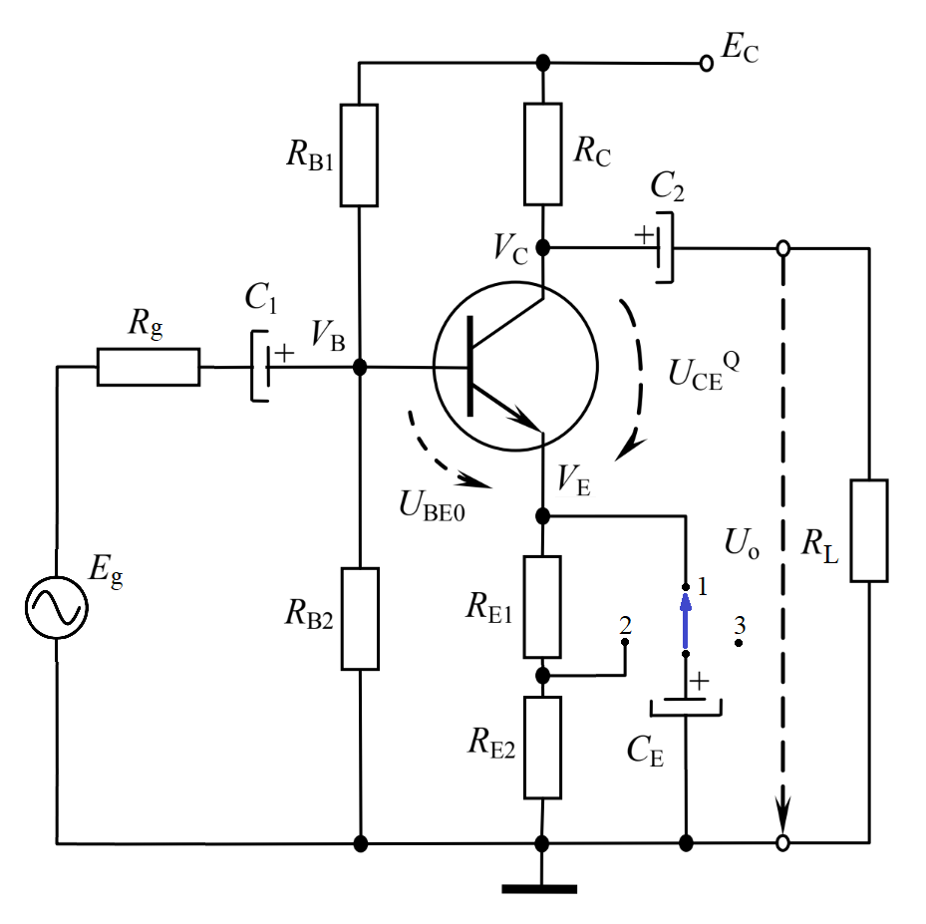

* ***Components***

1. *EC – DC Voltage Source*
2. *Eg – AC Voltage Source*
3. *npn Transistor*
4. *C1 , C2 – Capacitors*
5. *CE – Emitter Capacitor*
6. *RB1 , RB2 – Base Resistors*
7. *RC – Collector Resistor*
8. *RE1 , RE2 – Emitter Resistors*
9. *Rg – Input Internal Resistor (Eg)*
10. *RL – Load Resistor*

* ***Values***

|  |  |
| --- | --- |
| * EC = +5V * C1 = C2 = 4.7µF * RC = 2.2kΩ * RB1 = 22kΩ * RE1 = 100Ω * RL = 10kΩ * = 100 * SWITCH K: K 1, K 2, K 3 | * CE = 470µF * RB2 = 10kΩ * RE2 = 900Ω * Rg = 50Ω * = h21e = 307/25°C |

* ***Theoretical Analysis & Calculations***
* ***DC Analysis***

|  |
| --- |
|  |

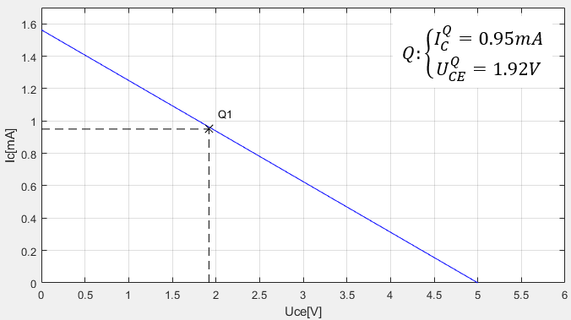

* ***AC Analysis***

1. ***K 1:***

|  |
| --- |
|  |
|  |

1. ***K 2:***

|  |
| --- |
|  |
|  |

1. ***K 3:***

|  |
| --- |
|  |
|  |

* ***Experimental Model***

|  |  |
| --- | --- |
| ***K 1*** | ***K 2*** |
|  |  |
| ***K 3*** | |
|  | |

* ***Measurements***

|  |
| --- |
| ***K 1*** |
|  |
|  |
| ***K 2*** |
|  |
|  |
| ***K 3*** |
|  |
|  |

* ***Simulations***

|  |
| --- |
| ***K 1*** |
|  |
|  |
|  |
| ***K 2*** |
|  |
|  |
|  |
| ***K 3*** |
|  |
|  |
|  |

* ***Table***

|  |  |  |  |
| --- | --- | --- | --- |
|  | ***K 1*** | ***K 2*** | ***K 3*** |
| ***Calculation*** | ***-68.4*** | ***-14.21*** | ***-1.74*** |
| ***Experimental*** | ***-51.43*** | ***-13.36*** | ***-1.76*** |
| ***Simulation*** | ***-68.5*** | ***-13.65*** | ***-1.75*** |

* ***Conclusion***

The BJT can be used as an AC voltage amplifier and depending on the resistance RE before the emitter capacitor we can change the voltage gain from the input voltage to the output voltage, the lower the resistance the higher the absolute voltage gain and the higher the resistance the lower the absolute voltage gain( ).

As the output voltage waveform appears to deform from the input sinusoidal waveform.